# **Name: Abdurrahman Qureshi**

# **Roll No: 210451**

Practical No: 9

1. **Theme Change Via Radio Box**

**CODE:**

Public Class Form1

Private Sub DarkModeBtn_CheckedChanged(sender As Object, e As EventArgs) Handles DarkModeBtn.CheckedChanged

If DarkModeBtn.Checked Then

PictureBox1.Image = Image.FromFile("C:\Users\Gold Roger\Desktop\College\SEM 4\GUI\Manual Apps\Darkmode\darkmodepic.png") End If End Sub

Private Sub LightModeBtn_CheckedChanged(sender As Object, e As EventArgs) Handles LightModeBtn.CheckedChanged

If LightModeBtn.Checked Then

PictureBox1.Image = Image.FromFile("C:\Users\Gold Roger\Desktop\College\SEM 4\GUI\Manual Apps\Darkmode\lightmodepic.png") End If End Sub

Private Sub Form1_Load(sender As Object, e As EventArgs) Handles MyBase.Load

Me.BackColor = Color.FromArgb(30, 30, 30)

DarkModeBtn.Font = New Font("Comic Sans MS", 14.0)

DarkModeBtn.Size = New Size(350, 50)

DarkModeBtn.Text = "Dark Mode"

DarkModeBtn.BackColor = Color.AntiqueWhite

DarkModeBtn.TextAlign = ContentAlignment.BottomCenter

'DarkModeBtn.BorderStyle = FormBorderStyle

' DarkModeBtn.BorderColor = RGB(255, 128, 128)

LightModeBtn.Font = New Font("Comic Sans MS", 14.0)

LightModeBtn.Size = New Size(350, 50)

LightModeBtn.Text = "Light Mode"

LightModeBtn.BackColor = Color.AntiqueWhite

ThemeTitle.Font = New Font("Comic Sans MS", 19.0)

ThemeTitle.Size = New Size(350, 50)

ThemeTitle.Text = "Radio Box - Theme Change"

ThemeTitle.BackColor = Color.AntiqueWhite

DesCription.Font = New Font("Comic Sans MS", 10.0)

DesCription.Size = New Size(350, 50)

DesCription.Text = "Select the desired theme and see the change"

DesCription.BackColor = Color.AntiqueWhite

End Sub End Class

**OUTPUT:**

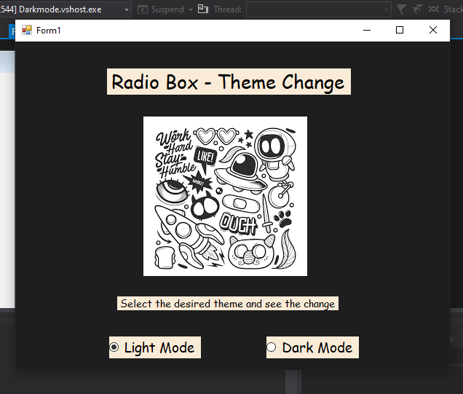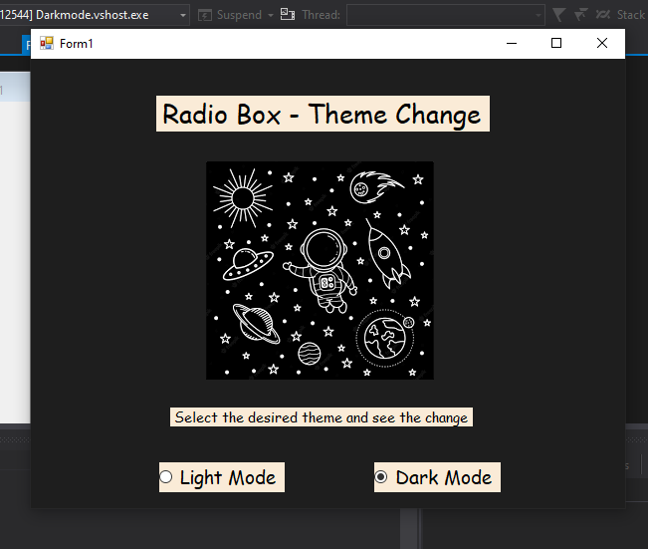

**2)** **Styling a String - Via Check Box**

**CODE:**

Public Class Form1

Private Sub Form1_Load(sender As Object, e As EventArgs) Handles MyBase.Load

'Header Title

topHeader.Location = New Point(300, 50)

topHeader.Font = New Font("Comic Sans MS", 22.0)

topHeader.ForeColor = Color.CadetBlue

'Description

DesCription.Font = New Font("Comic Sans MS", 10.0)

DesCription.Size = New Size(350, 50)

DesCription.Text = "Select the desired theme and see the change"

DesCription.BackColor = Color.AntiqueWhite

'Column Titles

BgLBL.Font = New Font("Comic Sans MS", 18)

BgLBL.ForeColor = Color.AntiqueWhite

TLBL.Font = New Font("Comic Sans MS", 18)

TLBL.ForeColor = Color.AntiqueWhite

LBLFF.Font = New Font("Comic Sans MS", 18)

LBLFF.ForeColor = Color.AntiqueWhite

'Background Color

BgRed.Font = New Font("Comic Sans MS", 15.0)

BgRed.Size = New Size(350, 50)

BgRed.Text = "Black"

BgRed.ForeColor = Color.AntiqueWhite

BgY.Font = New Font("Comic Sans MS", 15.0)

BgY.Size = New Size(350, 50)

BgY.Text = "Yellow"

BgY.ForeColor = Color.AntiqueWhite

BgW.Font = New Font("Comic Sans MS", 15.0)

BgW.Size = New Size(350, 50)

BgW.Text = "White"

BgW.ForeColor = Color.AntiqueWhite

'Font Color

TSB.Font = New Font("Comic Sans MS", 15.0)

TSB.Size = New Size(350, 50)

TSB.Text = "CadetBlue"

TSB.ForeColor = Color.AntiqueWhite

TPur.Font = New Font("Comic Sans MS", 15.0)

TPur.Size = New Size(350, 50)

TPur.Text = "Purple"

TPur.ForeColor = Color.AntiqueWhite

TGreen.Font = New Font("Comic Sans MS", 15.0)

TGreen.Size = New Size(350, 50)

TGreen.Text = "Green"

TGreen.ForeColor = Color.AntiqueWhite

'Font Family

RBTNR.Font = New Font("Comic Sans MS", 15.0)

RBTNR.Size = New Size(350, 50) RBTNR.Text = "Times New Roman"RBTNR.ForeColor = Color.AntiqueWhite

RBMono.Font = New Font("Comic Sans MS", 15.0)

RBMono.Size = New Size(350, 50)

RBMono.Text = "Ariel"

RBMono.ForeColor = Color.AntiqueWhite

RBF.Font = New Font("Comic Sans MS", 15.0)

RBF.Size = New Size(350, 50)

RBF.Text = "Fantasy"

RBF.ForeColor = Color.AntiqueWhite

Me.BackColor = Color.FromArgb(30, 30, 30)

End Sub

Private Sub RBTNR_CheckedChanged_1(sender As Object, e As EventArgs) Handles RBTNR.CheckedChanged

If RBTNR.Checked Then

topHeader.Font = New Font("Times New Roman", 22.0, FontStyle.Bold)

End If End Sub

Private Sub RBF_CheckedChanged_1(sender As Object, e As EventArgs) Handles RBF.CheckedChanged

If RBF.Checked Then

topHeader.Font = New Font("Fantasy", 22.0, FontStyle.Bold)

End If End Sub

Private Sub RBMono_CheckedChanged_1(sender As Object, e As EventArgs) Handles RBMono.CheckedChanged

If RBMono.Checked Then

topHeader.Font = New Font("Arial", 22.0, FontStyle.Bold)

End If End Sub

'Back Color

Private Sub BgRed_CheckedChanged(sender As Object, e As EventArgs) Handles BgRed.CheckedChanged

If BgRed.Checked Then

topHeader.BackColor = Color.Black

End If End Sub

Private Sub BgW_CheckedChanged(sender As Object, e As EventArgs) Handles BgW.CheckedChanged

If BgW.Checked Then

topHeader.BackColor = Color.White

End If End SubPrivate Sub BgY_CheckedChanged(sender As Object, e As EventArgs) Handles BgY.CheckedChanged

If BgY.Checked Then

topHeader.BackColor = Color.Yellow

End If End Sub

'Font Color

Private Sub TPur_CheckedChanged(sender As Object, e As EventArgs) Handles TPur.CheckedChanged

If TPur.Checked Then

topHeader.ForeColor = Color.Purple

End If End Sub

Private Sub TSB_CheckedChanged(sender As Object, e As EventArgs) Handles TSB.CheckedChanged

If TSB.Checked Then

topHeader.ForeColor = Color.CadetBlue

End If End Sub

Private Sub TGreen_CheckedChanged(sender As Object, e As EventArgs) Handles TGreen.CheckedChanged

If TGreen.Checked Then

topHeader.ForeColor = Color.Green

End If

End Sub

End Class

**OUTPUT:**

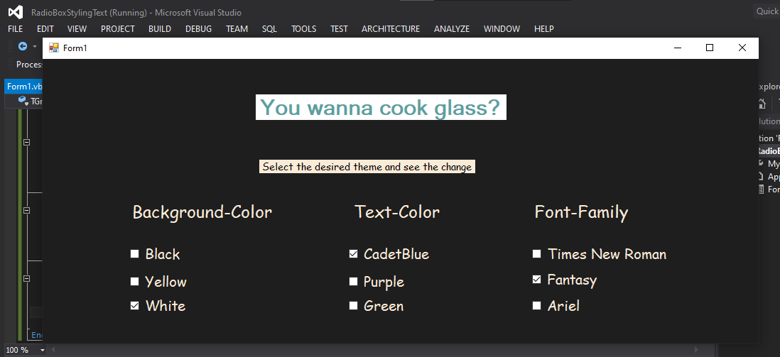

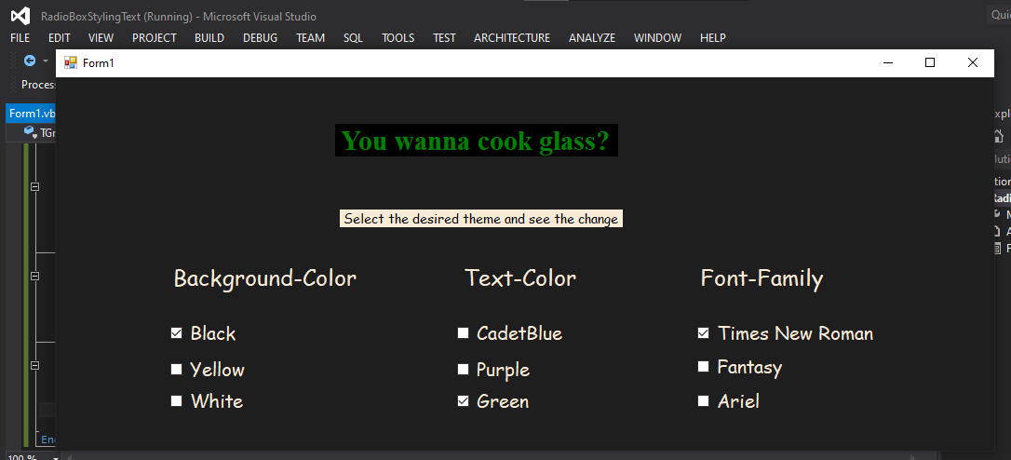 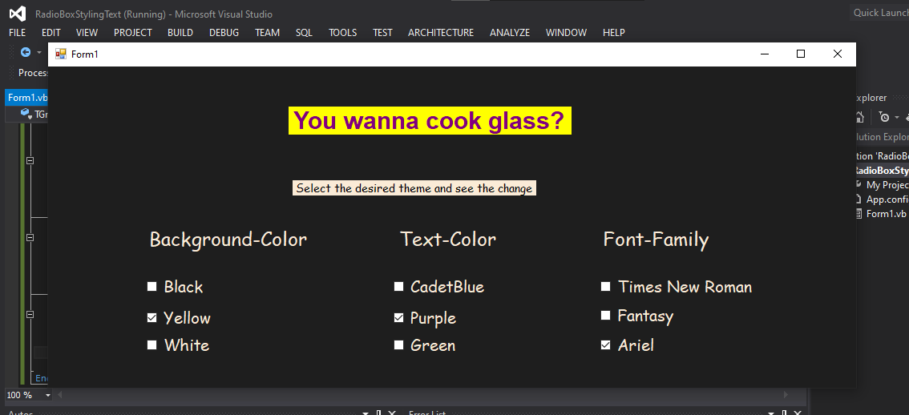

**3)** **Concatenating a String - Via Check Box**

**CODE:**

Public Class Form1

Dim str As String = ""

Dim cancelBtn As New Button()

Private Sub Form1_Load(sender As Object, e As EventArgs) Handles MyBase.Load

LblYo.Text = "Yo"

LblYo.Font = New Font("Comic Sans MS", 20.0)

LblYo.ForeColor = Color.AliceBlue

LblMr.Text = "Mr. White"

LblMr.Font = New Font("Comic Sans MS", 20.0)

LblMr.ForeColor = Color.AliceBlue

YoCB.Text = "Add First"

YoCB.Font = New Font("Comic Sans MS", 15.0)

YoCB.ForeColor = Color.AliceBlue

MrCB.Text = "Add Second"

MrCB.Font = New Font("Comic Sans MS", 15.0)

MrCB.ForeColor = Color.AliceBlue

cancelBtn.Location = New Point(300, 300)

cancelBtn.Font = New Font("Comic Sans MS", 10.0)

cancelBtn.Size = New Size(100, 30)

cancelBtn.Text = "Cancel"

cancelBtn.BackColor = Color.AntiqueWhite

Sbtn.Location = New Point(100, 300)

Sbtn.Font = New Font("Comic Sans MS", 10.0)

Sbtn.Size = New Size(100, 30)

Sbtn.Text = "Submit"

Sbtn.BackColor = Color.AntiqueWhite

Me.Controls.Add(cancelBtn)

AddHandler cancelBtn.Click, AddressOf btnCancel_Click

Me.BackColor = Color.FromArgb(30, 30, 30)

End Sub

Private Sub btnCancel_Click(sender As Object, e As EventArgs)

Me.Close()

End Sub

Private Sub Sbtn_Click(sender As Object, e As EventArgs) Handles Sbtn.Click

If YoCB.Checked Then

str &= "Yo,"

End If

If MrCB.Checked Then

str &= "Mr. White"

End If

MsgBox(str)

str = ""

End Sub

End Class

**OUTPUT:**

